Student Name: Calvin Moylan

Student ID: 30018702

Date: 23/10/2020

Assessment Title: Portfolio One

## AT 2: Activity 7

## Design Specifications

This application is one that needs to transfer data files such as CSV. It will transfer these files over sockets in a client to server like application.

## Design Specifications Analysis

For this task, I have followed all requirements which includes having a client and server application which communicates over sockets. The client can send a file to the server which will then read and then write the file. I chose to have the server choose where the file is written to by allowing for the server to choose by specify a directory.

## Debugging

Receiving file: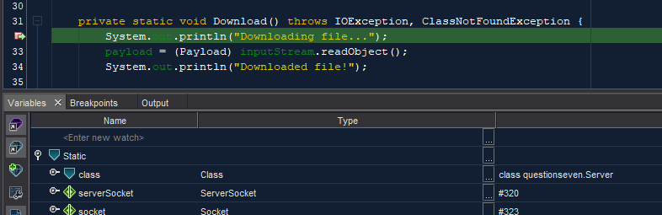  
Getting file data:  
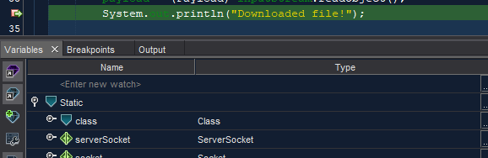  
Writing file to directory:  
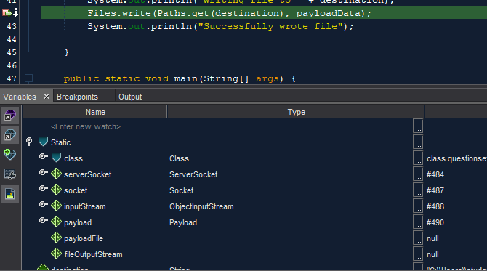

## Testing the Application

### Test and validate with sample inputs with screenshots.

|  |  |  |  |  |
| --- | --- | --- | --- | --- |
| **#** | **Test Case** | **Data** | **Expected Result** | **Actual Result / Comment** |
| *Case 1* | *Connecting to the server* | *Server IP and Port and file path* | *Client connects* | *Results as expected.*  *Ref Figure 1.1* |
| *Case 2* | *Connecting to server when not online* | *Server IP and Port and file path* | *Loops until server connects* | *Results as expected.*  *Ref Figure 1.2* |
| *Case 3* | *Client sends file* | *Server IP and Port and file path* | *Client sends file* | *Results as expected.*  *Ref Figure 1.3* |
| *Case 4* | *Server receives file* | *Sent file data* | *Server has file data* | *Results as expected.*  *Ref Figure 1.4* |
| *Case 5* | *Server writes file to disk.* | *Sent file data and writing path* | *Server writes file data to disk.* | *Results as expected.*  *Ref Figure 1.5 & 1.6* |



Figure 1.1

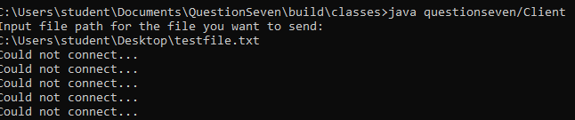

Figure 1.2

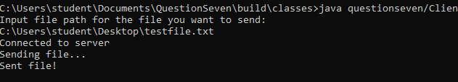

Figure 1.3



Figure 1.4

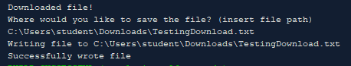

Figure 1.5

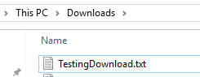

Figure 1.6

END OF TEST TABLE

## Implementation

The application has been uploaded to GitHub under the url: <https://github.com/CalvinMoylanTAFE/JavaThreePortfolio/tree/main/QuestionSeven>  
Here we will be able to update the repository if any future changes are necessary such as a bug fix or a future feature. The application can be implemented on any computer that supports Java Runtime Environment so deploying the application will require JavaRE to be installed.